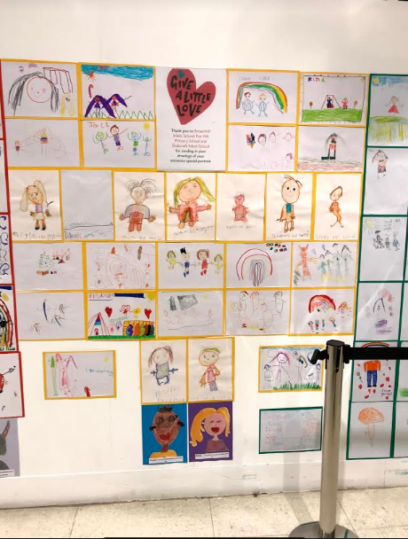
Our lovely artwork being displayed in John Lewis

