WALT- interpret data in a tally chart w/c 30/11/20
WILF: I can recognise the numbers on my tally chart. I can represent numbers using pictures. I can tell you what my tally chart shows

  Percy | I
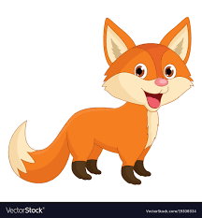  Fox | I
  Squirrel | I
  Hedgehog | III
  Mice | II
  Rabbit | IIII
  Badger | I

Can you answer these questions?
Question | Response
How many foxes are there?

Which has the highest tally?

How many more Mice are there than Squirrels?

