WALT- interpret data in a tally chart w/c 30.11.20
WILF: I can recognise the numbers on my tally chart. I can represent numbers using pictures. I can tell you what my tally chart shows

Mary 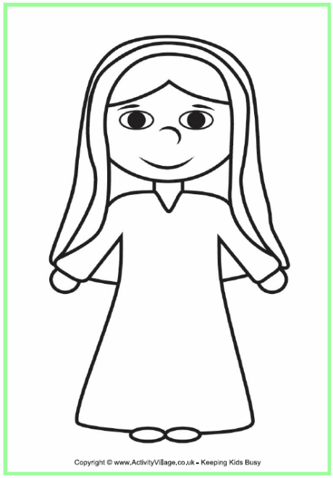 | I
Joseph 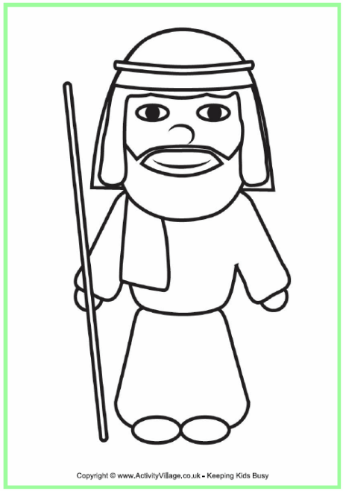 | I
Baby Jesus  | I
Kings  | III
Shepherd 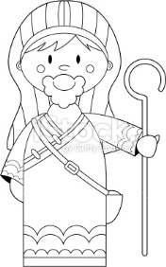 | II
Sheep  | IIII
Star  | I

Can you answer these questions?
Question | Response
How many kings are there?

Which has the highest tally?

How many more sheep are there than kings?

Can you answer these questions?
Question | Response
How many kings are there?

Which has the highest tally?

How many more sheep are there than kings?

Can you answer these questions?
Question | Response
How many kings are there?

Which has the highest tally?

How many more sheep are there than kings?

Can you answer these questions?
Question | Response
How many kings are there?

Which has the highest tally?

How many more sheep are there than kings?

