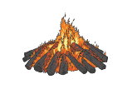
WB 03.11.20
WALT: Tell people how to be safe near a bonfire
Hear sounds in the words we want to write

I can say a sentence I want to write. |  |  |  | I can segment the sounds in words. |  |  | I can write some letters to represent the words I want to write. |  |  | I can say what the marks I make mean  I can say what the marks I make mean.  I can say what the marks I make mean.

