https://www.easypeasyandfun.com/rainbow-crafts-for-kids/
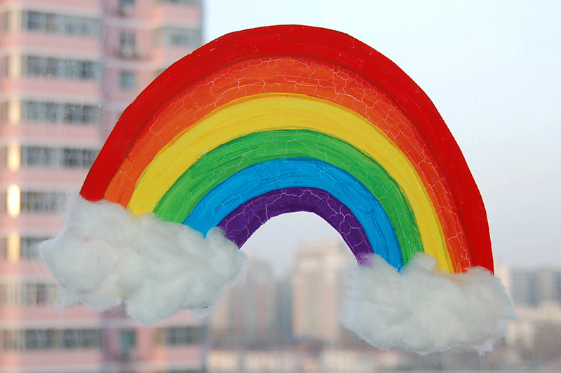
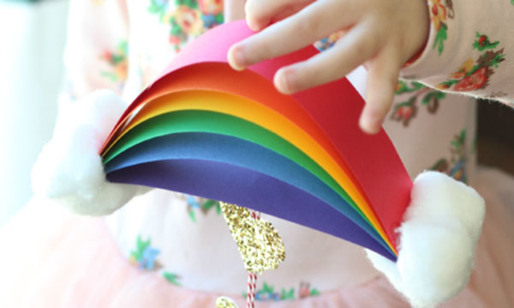
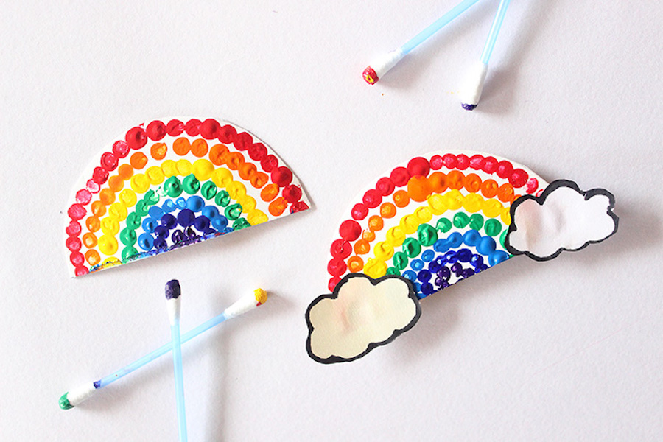

Make transparent sun catchers using PVA and food colouring:
Watch the youtube video here:
https://www.youtube.com/watch?v=RDz3sPp862A
