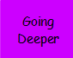
Challenge

Using the results you have already got in your table, can you work out which packets Augustus would buy to get:

24 sweets

30 sweets

35 sweets

19 sweets

