Key Learning: to name and describe 3D shapes 30.6.20
Success Criteria:
I can name 3D shapes (sphere, cylinder, cube, cuboid, cone, pyramid, triangular prism)
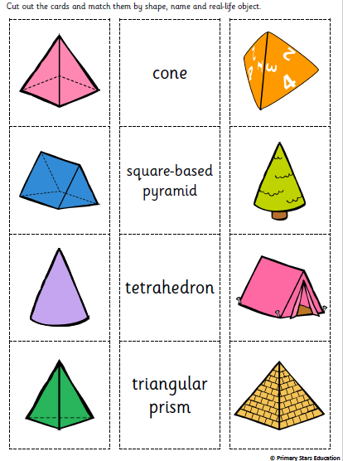
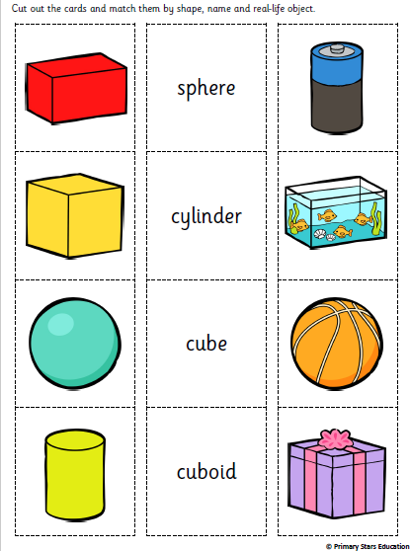
I can describe 3D shapes by their properties (vertices, edges, faces)
triangular-based pyramid

