Solve the multiplication or division missing box equations.
Independent
Label the parts and whole and draw a bar model or part-part-whole model to help you!
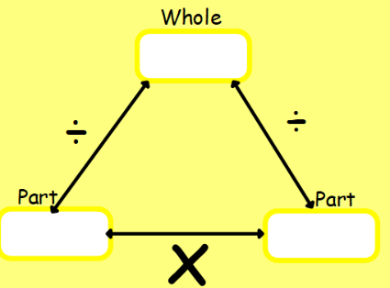
30 ÷ ________ = 3

5 x 2 = ________

2 x ________ = 6

_______ ÷ 5 = 4

_______ x 10 = 40

