Key Learning: to complete multiplication and division missing box equations 26.6.20
Success criteria:
- I can label the parts and whole in multiplication and division equations
- I can solve multiplication and division missing box equations
Consider and Practise
Label the equation with the parts and whole, then fill in the part-part-whole and the bar model:
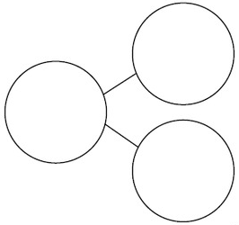

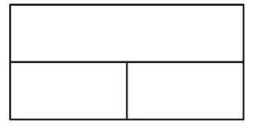
W
P
P

25 ÷ 5 = 5

4 x 10 = 40

7 x 2 = 14

