WALT: Draw and colour using complimentary colours w/c 22nd June Art task
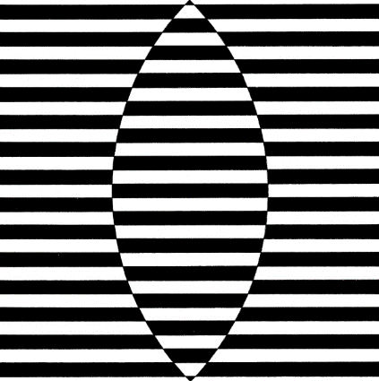
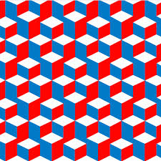
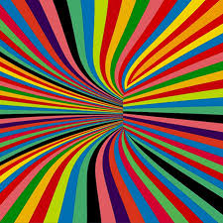

Bridget Riley is a British artist who uses combinations of different lines to create optical illusions in her artwork. This was known as ‘op art’. Sometimes she uses different colours, other times she uses light and dark lines.
Find out more about Bridget Riley using this link to the Tate kids website https://www.tate.org.uk/kids/explore/who-is/who-bridget-riley
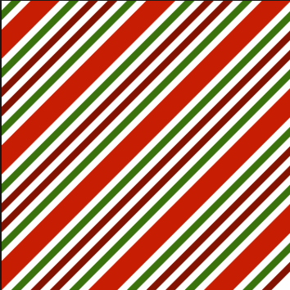
Task 1
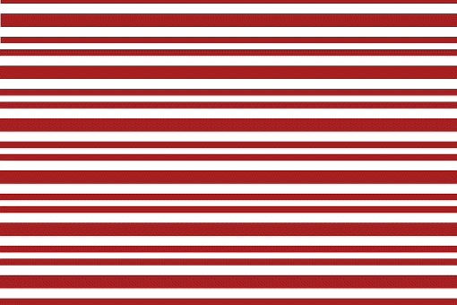
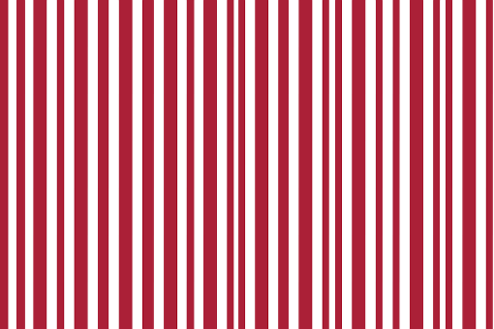

Using your pencil have a go at creating a pattern using light and dark lines to create a pattern.
You can use horizontal, vertical and diagonal lines. Can you create an optical illusion using them? Can you use complimentary colours to fill in your lines.

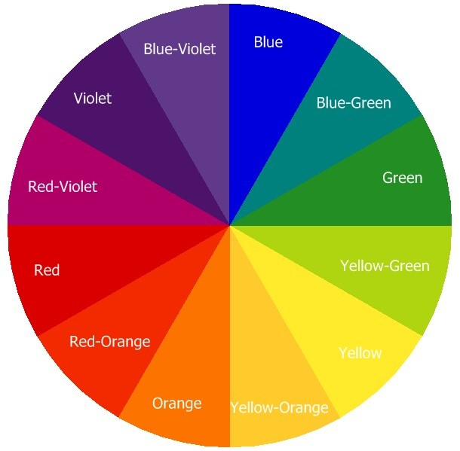
These are colours which are opposite each other on the colour wheel. When complimentary colours are placed next to each other they look much brighter.

Task 2
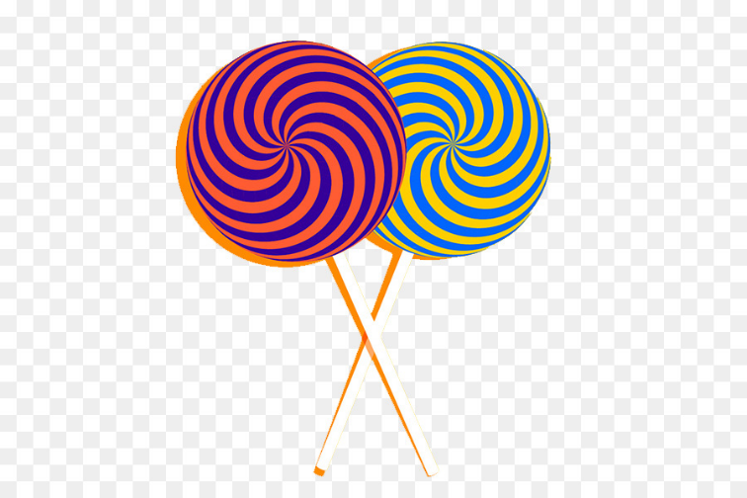
Can you use complimentary colours to create your own Bridget Riley style ‘op art’ lollipop?

Use bright and bold colours for a lollipop that is tempting enough for Willy Wonka’s chocolate room! You can use the template on the page below or create your own. You could even use some cardboard you’re your recycling to create your art work. You could use crayons, paints or felt tips for your lollipop.

