
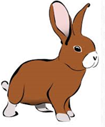

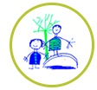
Daily challenges: ‘Imagine’
Refugee week and Recycle Now are events taking place in June. Some of this week’s challenges are linked to these events. Further information and activities for children can be found in the links below. Please send pictures for us to share on the website or twitter.
Take a virtual tour of the artic.  What can you see, hear?  https://baleinesendirect.org/en/arctic-adventure-a-virtual-expedition-on-the-ice-floes-for-elementary-school-kids/  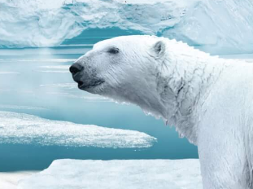 | Fact:  Earthworm bodies are slimy, and covered in tiny and stiff hairs. This helps them to burrow and wriggle through the soil. (Fact from RHS Under your feet).  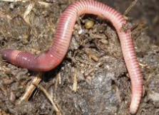  Find 5 amazing facts about our planet or animals on it. | Refugee week: Simple act  What would you do to welcome a new child into your class? | Read the poem below, how does it make you feel?  I will not limit myself  I will not be afraid  If it were not imagined  How else could it be made?  Lemn Sissay  Write a poem or short story starting with ‘Imagine if…’ or ‘Imagine a world where…
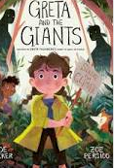  Ring a friend or grandparent and read your favourite book.  Enjoy, one of my favourites.  https://www.youtube.com/watch?v=GcCgn7QTAXw  Research: Greta Thunberg  https://www.natgeokids.com/uk/kids-club/cool-kids/general-kids-club/greta-thunberg-facts/ | Create a fluffy planet Earth    You will need: paper plate, shaving foam, pva glue, food colouring, paint brushes.  https://www.funlittles.com/earth-day-art-with-puffy-paint-earth/ | Read or listen to the story ‘The tiger that came to tea’ Judith Kerr.  https://www.channel4.com/programmes/the-tiger-who-came-to-tea  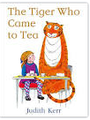  Can you retell the story to an adult?  Which animal would you like to come to tea?  Which country was Judith Kerr born? | Listen to Holst, The planets Jupiter, bringer of jollity.  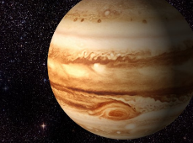  https://www.classicfm.com/composers/holst/pictures/holsts-planets-guide/jupiter-1/  Can you create music for planet Earth?
Draw, paint or craft about the world you want to see. 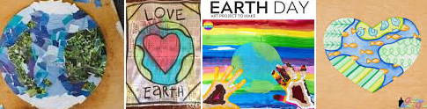 | Earth toast  Paint the planet Earth onto a slice of toast with food colouring.  Place in the toaster, look at how the colour changes- it becomes drier.  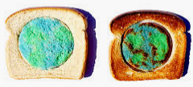 | How would you help the planet with climate change?  E.g. top tips to recycle  Help the ocean by taking litter home  How many can you think of? Create a poster.  https://www.nationalgeographic.com/family/6-save-the-earth-tips-for-kids/ | Make sandwiches, cake or biscuits for your animal to come to tea.  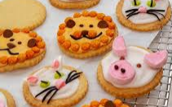
Further resources and information at https://www.kazzum.org/refugee-week-2020/primary https://www.globalrecyclingday.com/resources/

