Lesson 1 18.06.20
Key Learning: to apply my knowledge of multiplication and division
Success criteria:
I can count in multiples of 2, 5 and 10

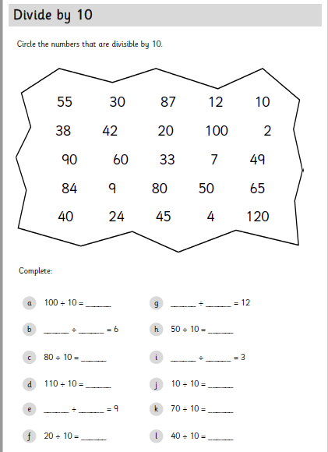
I can solve two step investigations using multiplication and division

