Lesson 2 16.06.20
Key Learning: to solve multiplication and division equations
Success criteria:
- I can complete multiplication and division equations
- I can use the inverse to check my answer

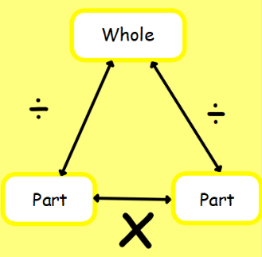
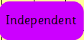
Copy the equations into your book and solve.

3 X 2 = 10 ÷ 5 =

1 X 10 = 80 ÷ 10 =

5 X 8 = 20 ÷ 2 =

4 X 5 = 4 ÷ 2 =

