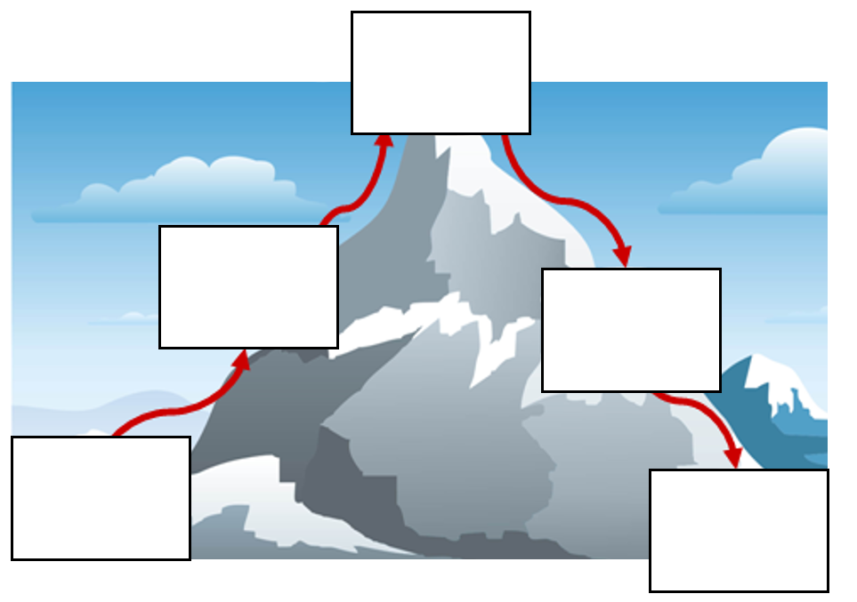
.
Resolution
Problem
Build up
Ending
Introduction

