97 | 50 | 61
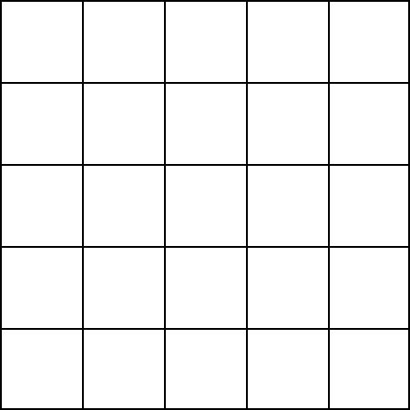
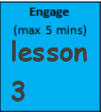
Key Learning: Add 10s to a number within 100
Can you draw the tens and ones for these numbers? Remember we draw lines for the tens and dots for the ones.

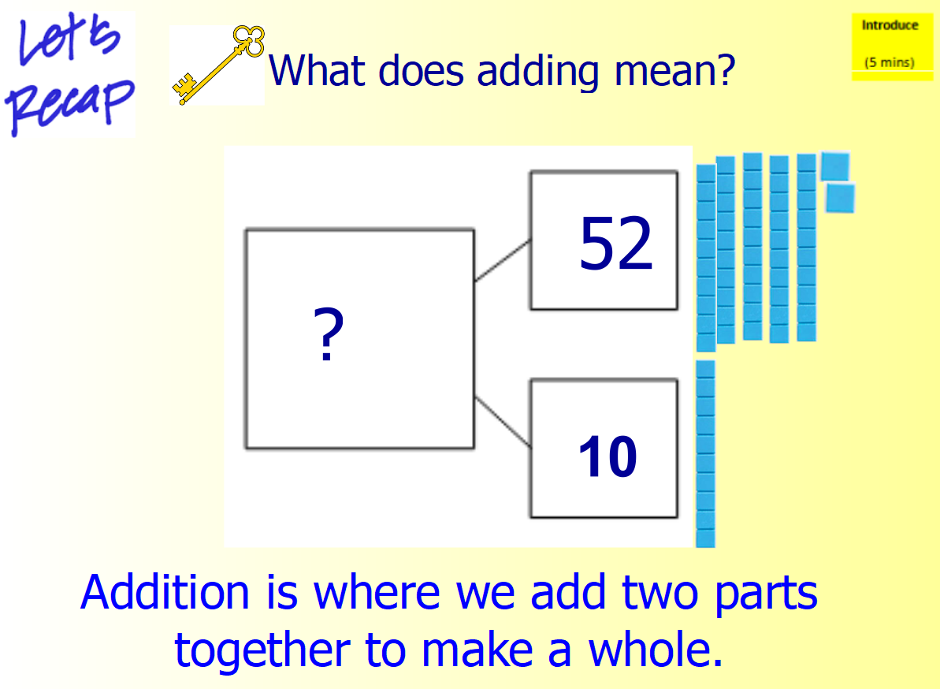

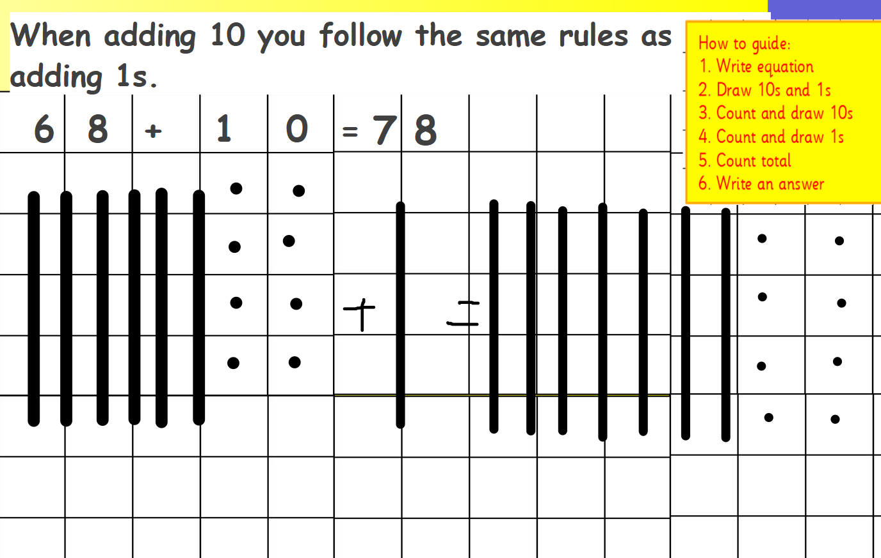
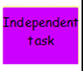

Can you draw the dienes to work out the answers to these equations?
Spicy
- 39 + 20 =

- 50 + 30=

- 43 + 20=

- 69 + 30=

- 22 + 30=
Hot
- 26 + 40=

- 30 + 40=

- ? = 51 + 20

- ? = 30 + 30

Mild
- 15 + 10=

- 20 + 10 =

- 31 + 10 =

- 65 + 10 =

