
Equation Dienes
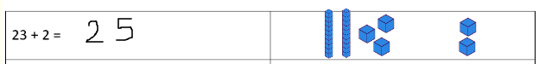
Write the answer next to the equation. You can draw the dienes in this box to help you.
10 – 4 =
59 – 3 =
11 + 6 =
26 + 4 =
38 – 5 =
14 + 4 =
47 + 3 =
59 – 9 =
34 + 5 =
66 – 2 =

