Welsh Day!!! 
Links and powerpoints and resources are in the staffshare
What is it? Where is it? | Has anyone been to Wales? Can they tell you anything about it?  On Google Earth – look at Sheffield – fly to wales by typing in Wales  Look at the coastline and talk about beaches  Talk about the capital city, Cardiff  Look at the flag
Draw a map/ colour a flag | See staffshare for blank and coloured flag
Look at either (or both) of the powerpoints about wales | Talk about the pictures – beaches, castles, food.
Acrostic poem about wales | See template in folder
Make a welsh dragon  Design a dragon for sheffield | Make from Lego or collage or blocks or junk modelling or  Draw a dragon that might go on a flag for Sheffield.
Welsh music  Welsh people are famous for having great singing voices  Have a dance around to these welsh bands! | https://www.youtube.com/watch?v=DRtnWVvDX6k man of harlech  https://www.youtube.com/watch?v=zydIvSDXS7Y – Tom jones singing It’s not unusual at Tea in the Park (please check for swearing!)  https://www.youtube.com/watch?v=U_bL0EqlDEk Catatonia – road rage  https://www.youtube.com/watch?v=AARrVAHnkdY Boys welsh choir on Britain’s got talent (2.00 minutes in to avoid all the judges blurb at the beginning)
Welsh dancing | https://www.youtube.com/watch?v=5_jMCsiYHTE  Can you have a go? Can you make up your own?
The national flower for Wales is the daffodil. | Make paper daffodils  Still life drawing of daffodils  Plasticine daffodils  Daffodil necklace, headband, hat etc  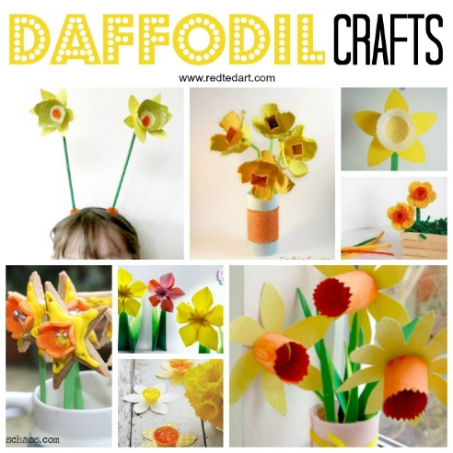
Welsh national costume | Look at the pictures at the bottom of this document! Imagine getting dressed up like that every day!  Make a welsh hat  Draw a welsh costume
Welsh children in the past | Look at the powerpoint ‘Children at work’ I have tried to make is not to depressing! I thought children might like to see that at their age, they’d be expected to have a job! Short powerpoint for looking at with snack or milk.
Build a Welsh castle | Construction area or lego.
Make a fact sheet or zig zag book – what have we learned about wales?

Resources:
https://www.theschoolrun.com/homework-help/wales - good images of wales to look at as a whole class
If you have a twinkl log in:
https://www.twinkl.co.uk/resource/t2-g-310-wales-uk-lesson-teaching-pack
https://www.twinkl.co.uk/resource/t-g-185-new-wales-information-powerpoint

National costume:
