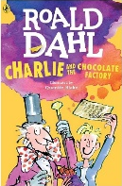
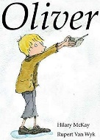
Summer Term 1: Week 6 reading task

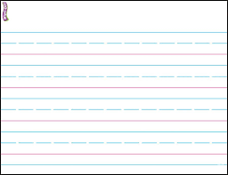
Just “Oliver Twist “ Similarities between both stories Just “Charlie & the Chocolate Factory”

