Summer Term 1: Week 6
Reading task: comparing two stories or characters

Hi Year 2! Reading is really important, and hopefully you’ve been re-reading your favourite books or reading some new books for the first time whilst you’ve been at home.

I want you to see if you can compare two stories or characters from books you know really well.
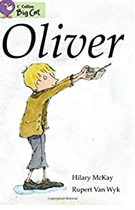
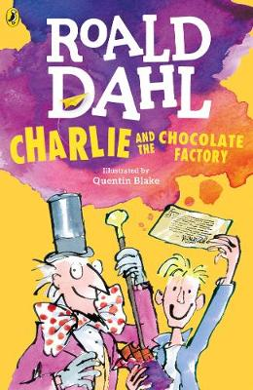
You can use the template that compares Oliver Twist and Charlie and the Chocolate Factory that is on the website, or you can choose your own stories.

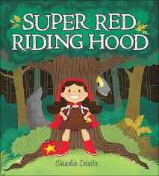
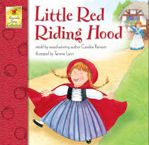
Maybe you have two versions of the story written by two different authors, such as these versions of Little Red Riding Hood?

Maybe you have two stories that tell the same story from different characters’ point of view, like The Three Little Pigs and The True Story of the 3 Little Pigs?
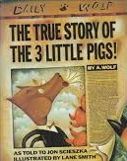
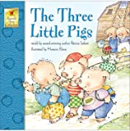

Think about:

- the setting of the story
- the characters
- the problem
- the hero/villain

What is similar and what is different about your two stories?

Happy reading!

