Summer Term 1 Week 6:
Art Task: Create your own picture in the style of Andy Warhol/ pop art.
Andy Warhol was an American artist and he created many famous paintings and pictures in the style of pop art.
Pop art is inspired by things in popular culture (fashion, music or famous people). Andy Warhol liked to use bright colours and lots of repeated patterns:
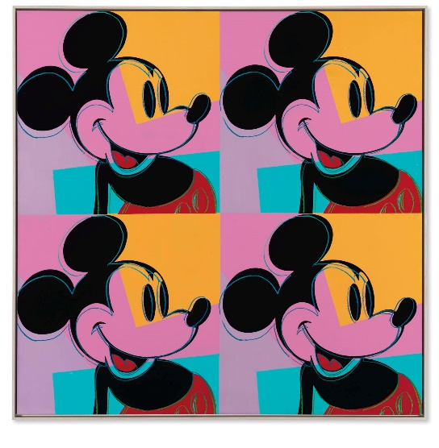
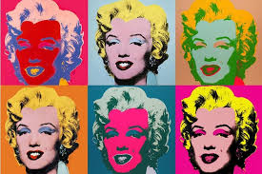

This is a picture of the famous movie star Marilyn Monroe.
In this picture of Mickey Mouse he has used the same colours and the same patterns.

He has used different bright colours for each picture!
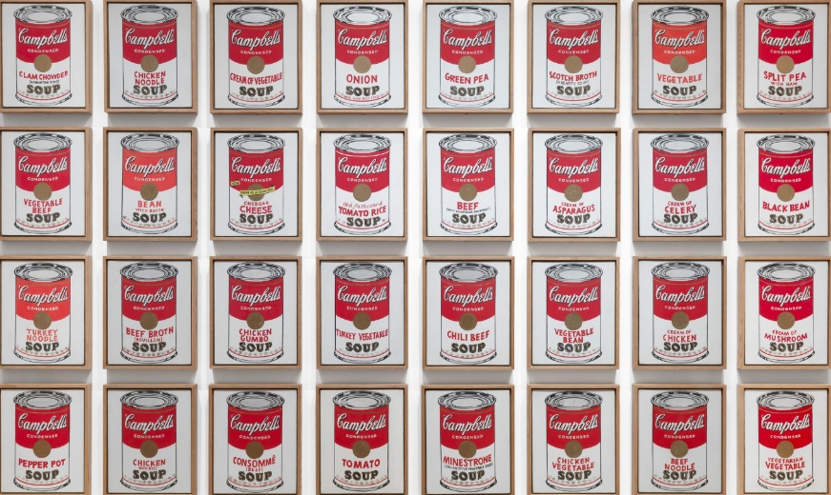
Andy Warhol even made tins of soup famous!
This was a painting that he made in 1962 and it was called ‘Campbell’s Soup Cans’.
To make this painting he used projection (shining a picture of the tins onto the canvas), tracing, painting and stamping to make sure that they were all identical.

NOW IT’S YOUR TURN…

Make your own pop art creation! Remember to use lots of bright colours. You can either colour them all in the same colours (like the tins of soup paintings) or you can use different colours for each tin or star.

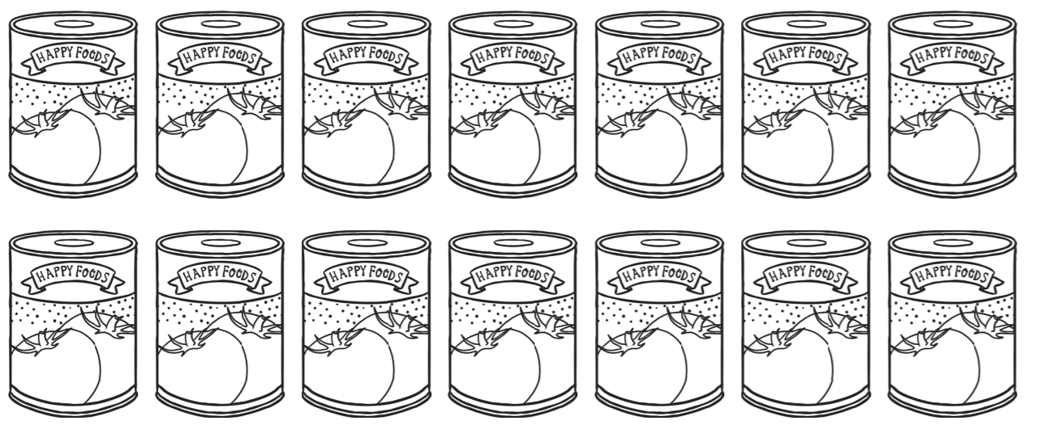

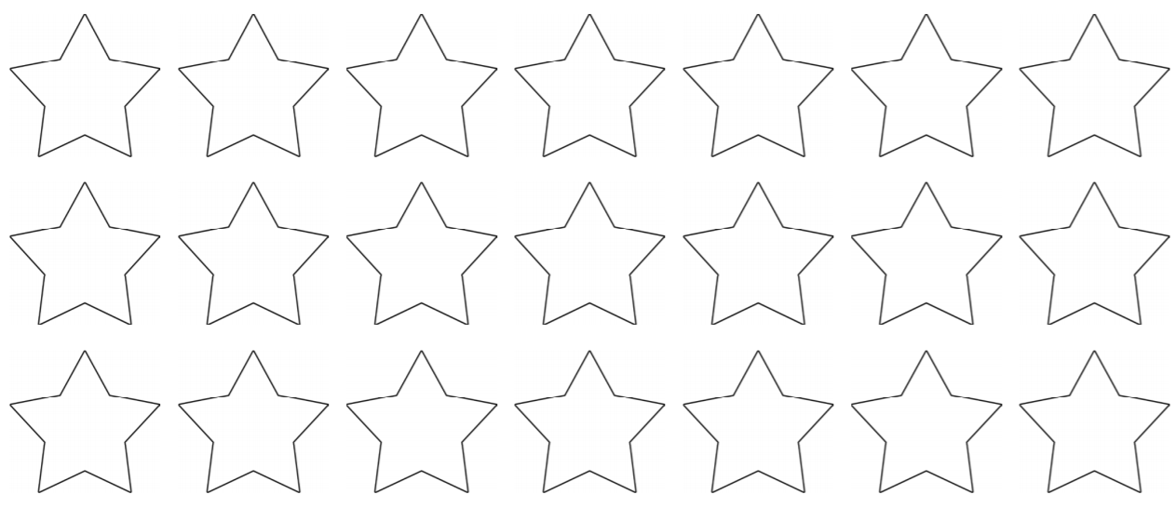


Create your own self portrait (a picture of yourself). Draw it four times and then colour it in with different bright colours in each picture.
You could copy a photograph of yourself! REMEMBER: all four pictures need to be identical!
1. 2.

3. 4.

