Summer Term 1: Week 6
English – Activity 2
Task 1
For your first task, we would like you to write some instructions on how to make a pizza. You can write the instructions out, and then have a go at making it and follow your instructions to see if it works!
Think back to the instruction writing you did a few weeks ago, and then instruction writing we have done this year in school.
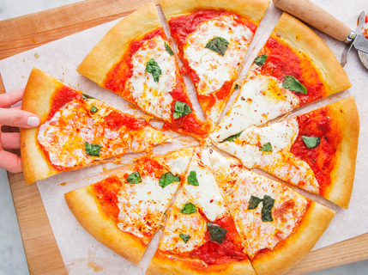
Include:
- A title
- Ingredients and equipment list.
- Instructions with ‘bossy verbs’ for your method. Make sure you bullet point your instructions, don’t number them. This is because you are going to do a re-ordering activity next!
- Decorate the border with pictures and images of your pizza!
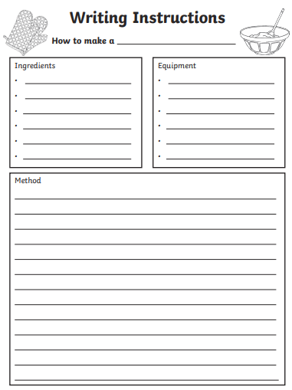
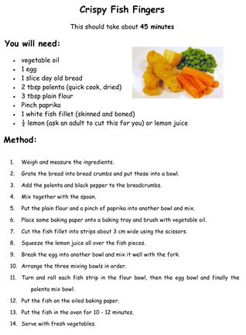

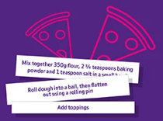
Task 2
Cut up your instructions into strips of sentences. Mix up the order of the instructions. Can you or a family member put them back into the correct order? How long did it take you or a family member to re-order them?

