
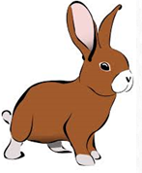

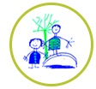
Daily challenges
Choose in any order and see if you can complete them all. Send pictures for us to share on the website or twitter.
Take a virtual tour of Windsor castle. Can you draw your own castle or make one out of boxes?  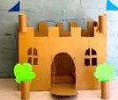  https://www.royal.uk/virtual-tours-windsor-castle | How do musicians know how to play together. Watch this short clip to find out. https://www.yourclassical.org/topics/classical-kids-corner  Then make some musical instruments (use bottles, pans, rice etc) and play together as a family. | Collect 4 sticks, 6 stones and 6 pine cones and make you own tic tac toe (noughts and crosses).  Then play with your family.  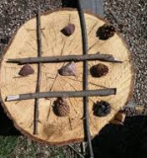 | Listen to Antonio Vivaldi’s The Four Seasons, Concerto for Solo Violin and String Orchestra.  Can you hear the difference between each season? Which is Autumn, Spring, Summer and Winter?  https://esme.com/single-mom-showcase/music/top-10-classical-pieces-kids-should-know
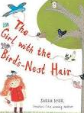  Ring a friend or grandparent and read your favourite book.  Listen to mine,’ The girl with  the bird’s nest hair’  https://www.youtube.com/watch?v=lcvFbLFjFEw | Virtual tour of the National History museum, take the Dippy tour.  https://www.nhm.ac.uk/take-part/dippy-on-tour.html  Can you draw a dinosaur?  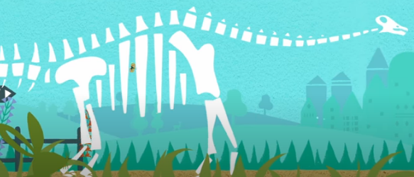 | Imagine if Dippy was a live and came to town. What would he do? What would he eat? Who would he make friends with?  Tell your story or write your own story or news article.   | In your garden or in your house, how many spider webs can you see?  Watch the very busy spider story  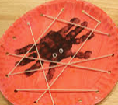  https://www.youtube.com/watch?v=TfL0g-XRxnA  Then create your own  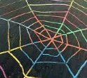  spider web art.
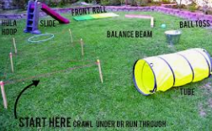  Make an obstacle course. How fast can you complete it? Challenge someone in your family to complete it. | Can you make an animal out of an egg box?  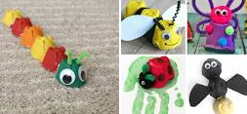 | Draw a picture of yourself, around it write all the things you are good at.  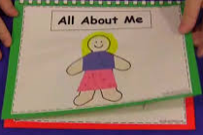 | Make and decorate biscuits like spiders.  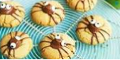  https://www.bbcgoodfood.com/recipes/spider-biscuits

