

Summer Term 1 Week 4:
English Task 3: Spelling games

As we haven’t been doing our weekly spelling lessons and Friday spelling sentences, Miss Hughes thought it would be a good idea to do some fun spelling activities to help our brains remember all the words we are learning how to spell in Year 2.
All the Spelling Zone planets and each spelling rule for Year 2 are on zappers in a Gallery Item already, so you can use those too, but here are some more activities to help you.

Activity 1: Unscramble the Spelling Zone words
ekbar ------------
irhcnled ------------
luohds -----------
eyyodbevr ---------
elowh -----------
Can you now put each unscrambled word in a sentence? Make sure you spell it correctly!
Activity 2: spelling strategies
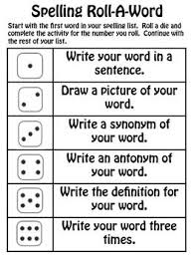
Use the different spelling strategies to create ways to remember words you find tricky.
You could use Lego or magnetic letters to spell out words, create mnemonics like “big elephants can always understand small elephants” = because,
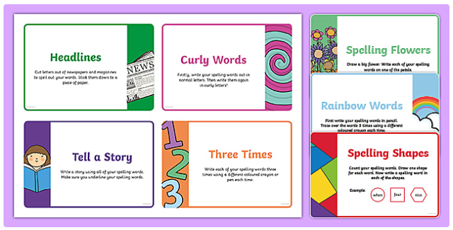
or write your word as many times as you can in a minute.
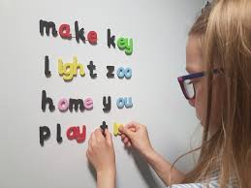
Activity 3: online games
Follow these links to play some online spelling games on your computer or tablet!
https://www.topmarks.co.uk/english-games/5-7-years/words-and-spelling
https://www.spellzone.com/word_lists/games-158181.htm
https://www.ictgames.com/mobilePage/literacy.html

