Summer Term 1 Week 4:
English Task 1: I am lucky because…
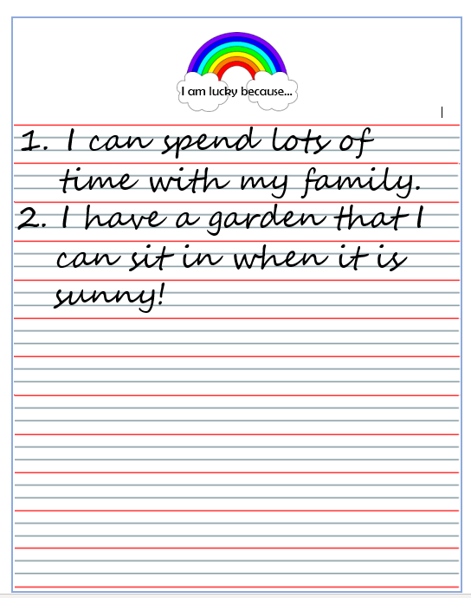
Think about all the things that you are grateful for while you have been at home.
Try to think of 5.
My example is below:

