Summer Term 1: Week 4
Topic Activity 1: Science experiment

Rainbow Walking Water Experiment
Have you ever wondered how a plant gets its water from the roots at the bottom to the petals at the top? Or how the water travels up a tree trunk to feed the leaves on its branches? Well today we are going to find out!
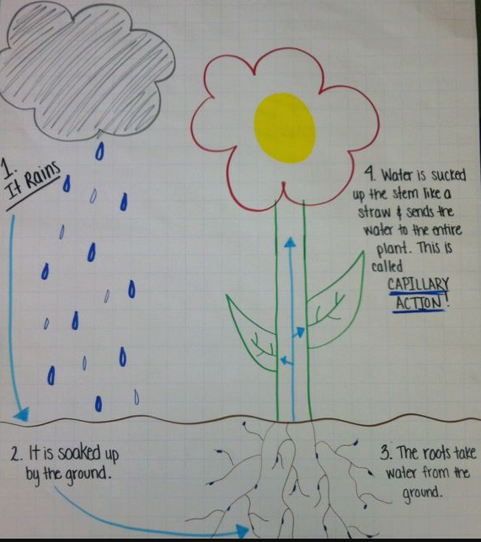
Capillary Action
Capillary action is the ability of a liquid to flow in narrow (small / thin) spaces without the help of external forces like gravity. In fact the liquid can even move in the opposite direction to gravity!
This is what happens in a plant. Water is soaked up by the roots in the ground, and the forced up the stem (a narrow space) to feed the leaves or petals. You could think of this as a bit like sucking a liquid up a straw!
Key Vocabulary
Capillary Action Gravity
Liquid Stem
Narrow spaces

Let’s see if we can now use this information to help us with our experiment, and hopefully watch the capillary action...in action!
Miss Mather and Mrs Machin have loved seeing so many drawings of rainbows in people’s houses on their daily walks and runs. How many rainbows have you spotted?
Seeing all of these beautiful rainbows has therefore given Miss Mather an idea – can we create our own rainbows using the idea of capillary action?
Follow the instructions on the next page to help you set up your experiment.

What will you need?
- 7 clear plastic cups, glasses or jars
- 6 pieces of kitchen roll
- Food colouring in the primary colours (red, blue and yellow)

- Water
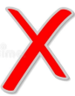
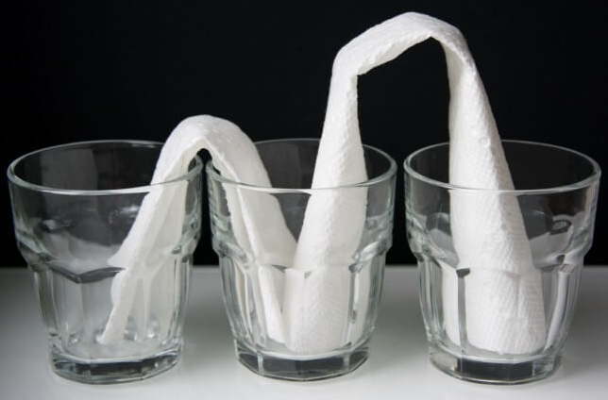
Method
Step 1: Place the 7 cups or jars in a line.
Step 2: Check the size of your kitchen roll. Fold the kitchen roll into a strip and place one end of the kitchen roll into the first jar, and the other end into the jar next to it. Repeat all the way down. Make sure the kitchen roll touches the bottom of each cup, and that there isn’t too much sticking out at the top of the cups (look at the picture)
Step 3: Once you have checked the size of the kitchen roll take them all out, but leave them rolled up.
Step 4: Pour water into the 1st, 3rd , 5th and 7th cup so that they are ¾ of the way full.
Step 5: Add 5 drops of red food colouring in the 1st and 7th cup. Add 5 drops of yellow food colouring in the 3rd cup. Add 5 drops of blue food colouring in the 5th cup.
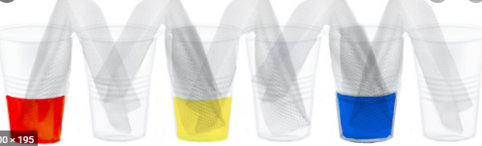
Step 6: MAKE YOUR PREDICTION! You are about to add in your strips of kitchen roll. But before we do that we need to predict what you think will happen to the water. Use the template sheet to write your prediction. Think about what we know about capillary action and mixing colours when writing your prediction.
Step 7: Add your strips of kitchen roll in between each cup. Make sure that the pieces of kitchen roll touch each other in the cups.

Step 8: Watch the cups and see what happens!
Step 9: Record your results on the template sheet.

There are lots of useful videos on YouTube on how to do this experiment if you need some extra help or guidance. Just make sure you don’t watch to the end – we don’t want to spoil what happens!

Rainbow Walking Water Experiment
PREDICTION - What do you think will happen to the water?
I predict that ..................................................................................................................................................
.........................................................................................................................................................................
This is because.................................................................................................................................................
...........................................................................................................................................................................

RECORDING – Draw a picture in the space below to show what happened. Can you label your picture to help explain it further?

EVALUATING – What happened to the water? Why do you think this happened (think about capillary action and colour mixing)? Was your prediction correct? Were you surprised by anything that happened? How could you improve next time?
I noticed that.....................................................................................................................................................
...........................................................................................................................................................................
I think this happened because...........................................................................................................................
.........................................................................................................................................................................
My prediction was...........................................................................................................................................
We could have improved the experiment by.................................................................................................

