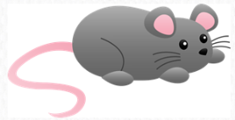
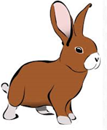

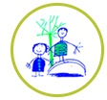
Daily challenges
Choose in any order and see if you can complete them all. Send pictures for us to share on the website or twitter.
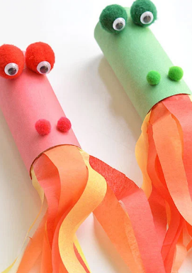  Make your own dragon, using a toilet roll, tissue paper and pomp oms or screwed up paper for eyes. Blow through the tube to make it breathe fire! | Make mud pies!  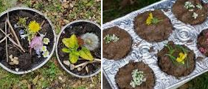 | Milk jug toss  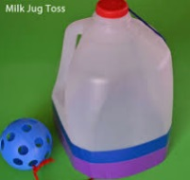  Cut the end off a clean milk bottle, decorate it. Using a small light weight ball, how many times can you throw it up and catch it? | Virtual tour of Edinburgh zoo, go and see pandas, koalas and lots more.    https://www.edinburghzoo.org.uk/webcams/panda-cam  Write a postcard after your visit.
We are going on a shape hunt…  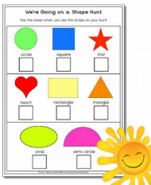  Walk around your house, how many of each shape can you count?  Which shape has the highest number?  Which shape has the lowest?  How many shapes can you see outside? | 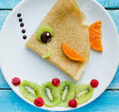  Make pancakes and use fruit to make a face or decorate it. | Listen to Saint Saens, Carnival of the animals. Choose the lion, flamingo, swans or there’s lots more to choose from.  https://www.yourclassical.org/story/2015/06/29/carnival-of-the-animals-saint-saens | Go on a walk and collect different leaves. Use crayons to do leaf rubbings.  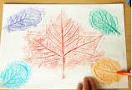
  Read a book off Bug club. Can you answer the questions? | 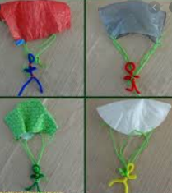  Use paper, string, toy figure (or one made from pipe cleaners) to make your own parachute. | Write what your superpowers are…  My superhero powers  I’m a really fast swimmer.    I’m thoughtful about other people’s feelings.  I’ve learnt how to draw birds.  I’m kind.  Draw yourself as a superhero. | Take your favourite toys on an adventure in your garden or build them a stick den then have a snack picnic with them after.  