Learn about context of USA first – which continent is it in? Look at google maps, record anything you already know about America. How many states are there? Name the capital city and any other cities you can. What languages do they speak?
- The statue of liberty –
Use lego / scrap shed/ construction equipment to see who can build the tallest/quickest/most realistic version of the statue of liberty in teams. (Could be done outside)

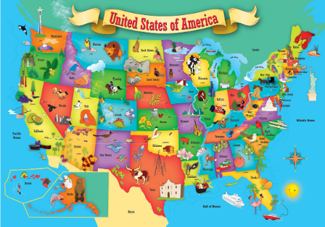
- MAP – can you create an outline of the USA and split it up into its states. Different parts of America are very different to each other. Can you add some landmarks, animals or items that part of America is famous for to your map?

- Food – different parts of America are famous for different foods.
Could you research and find a famous dish from different parts of America?
Could you try to make one of the foods for lunch? Take photos to share with Dobcroft!

- Group activity to collage the American flag.
This can then be used as a poster background to put photos / artwork on as an end result of the days learning (photo of this could be added to twitter) How many stars and stripes are there?

- Create your own line dance (using American country music) and upload a video for everybody to watch and try and dance along!

- Create your own Hollywood Star to add to the ‘Walk of Fame’. Take a photo of you unveiling it!!

- Create a fact sheet on particular part of the USA – where is it? What do they eat there? What animals are native to that area? Are there any famous landmarks? (children in school can each pick a different place and them add them all together to make a non-fiction text)

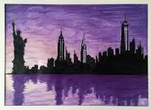
- History – Can you create a timeline of all the American presidents there have been and how long they served?

- Art – create a silhouette of the New York skyline

- American sports – play some American sports – Baseball/American football

