Summer Term 1 Week 3:
RE Task: Ramadan
Firstly, can you remember any of the religious symbol we have learnt about this year in RE?
We learnt about some symbols from different world religions including Christianity, Islam and Buddhism.
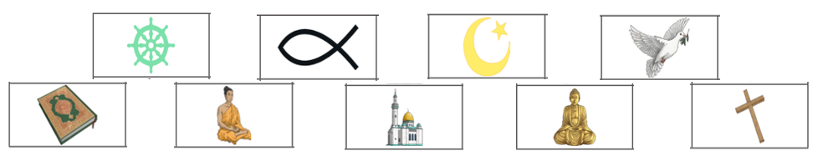
Here are some symbols to help jog your memories – can you explain what any of them represent?

Task:
Watch this clip on Newsround from Thursday 23rd April about Ramadan: https://www.bbc.co.uk/newsround/23286976
(You can also find it by searching “Ramadan newsround” into Google)

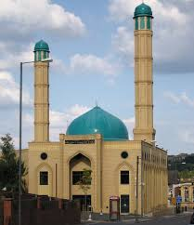
Can you explain why Ramadan might be a bit different for Muslims this year?

Make an informative leaflet or poster about Ramadan using the information on the website above, what you can remember from the school trip to the mosque we went to in the Autumn term and any other facts you can find out yourself.

Think about key symbols of the religion, how Ramadan will be a bit different this year and traditions of Ramadan.

Ramadan is also a time for spiritual reflection, prayer, doing good deeds and spending time with family and friends. Normally, people will make a special effort to connect with their communities and reach out to people who need help. You could also find out how Muslims are helping their communities at this time too.

