Summer Term 1 Week 3:
Music Task 1: Different instruments
Colour in the musical instrument mindfulness sheets. Write the name of the instrument at the top.
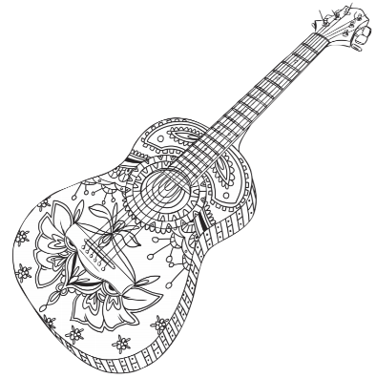
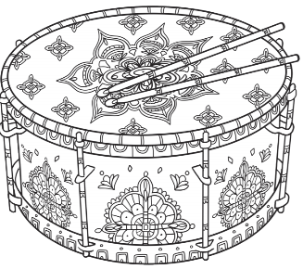

Click here to print them. The sheets are also attached on this post if you have trouble downloading them.

Task 2: Listen to David Walliams’ ‘Weird Instruments’ podcast.

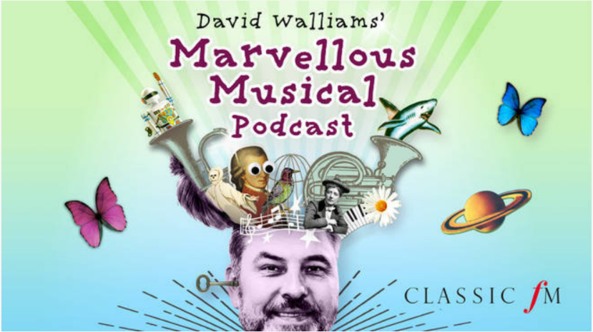

Here is the link: http://marvellousmusicalpodcast.com/

Listen carefully and complete the Clever Clogs Quiz!
