Summer Term 1: Week 3
English Task – Writing a postcard

Hi Year 2!
We hope you have had a lovely weekend in the sun with your families.
For your English task this week, Miss Shaw would like you to write a postcard to a family member or friend. I would like you to write about:
- What you have been doing at home.
- Who you have been spending time with.
- Your favourite activity you have done since you have been at home. This could be a learning task, or just something fun you have done!

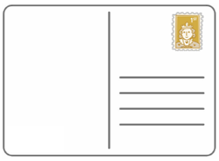
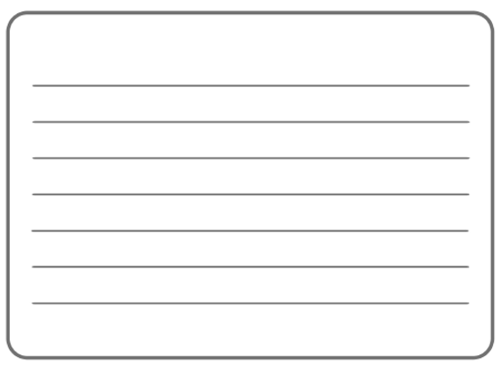
When you next see the person you have chosen to write your postcard to, you can give it to them so they can see what you have been up to! Take a picture of your postcard and send it to your teacher so they can see what you have been up to as well. We have attached a copy of the postcard templates onto the website if you would like to use them. Happy writing!

