
Miss Mather’s Springtime Flower Shop!
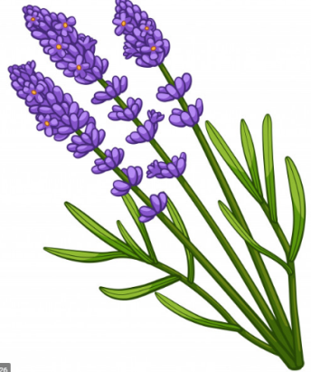

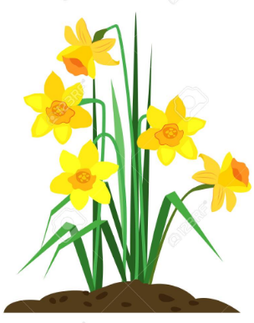
Miss Mather has been planting so many flowers in her garden she has decided to sell some to her friends and neighbours! Take a look at the flowers on sale and answer the questions below.
Tulips
82p
Daffodils
50p

Lavender
£3.50

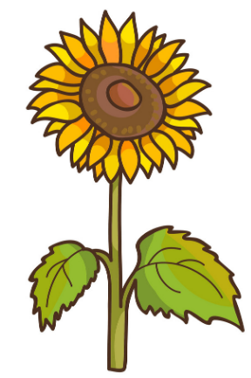
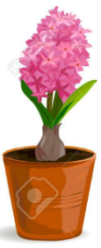
Hyacinth
£1.10
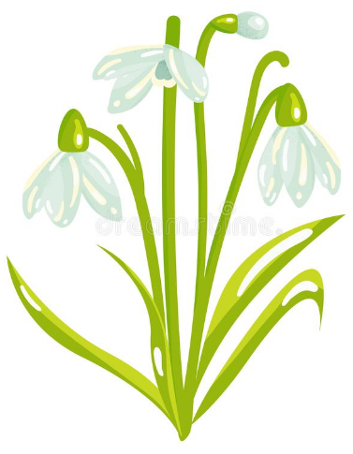
Snowdrops
£2

Sunflower
35p (each)

Mrs Machin goes to Miss Mather’s Springtime Flower Shop with a £2 coin and 3 £1 coins to spend.
- Mrs Machin buys the lavender and the daffodils. How much does she need to pay altogether?

- Mrs Machin buys 2 sunflowers, the hyacinth and the daffodils. How much does she need to pay altogether?

- Which coins could Mrs Machin use to buy the hyacinth and the daffodils? How much change would she get?

- Which coins could Mrs Machin use to buy the snowdrops and the tulips? How much change would she get?

- Mrs Machin wants to buys as many flowers as she can. How many different flowers could Mrs Machin buy with the money that she has? Can you think of more than one combination? Which combination do you think is the best and why?

- Mrs Machin thinks that she can buy the lavender and the snowdrops. Is she correct? Explain your answer.

- Mrs Machin buys two different flowers and spends exactly £1.60. Which flowers did she buy?

- Mrs Peersman comes to the shop with £2.50 to spend. How much more money does Mrs Machin have than Mrs Peersman?

- What flowers could Mrs Peersman buy that will use up all of her coins and not leave her with any change.

- If Mrs Machin and Mrs Peersman think that if they put their money together, they will be able to buy two bunches of lavender, and some tulips. Are they correct? Explain your answer.

When you have finished, think about which questions you enjoyed and which questions did you find tricky? Were there any strategies that you found successful in helping you to answer the questions?

