Summer Term 1: Week 3
Maths Activity 2 – Money (Adding coins)

Let’s quickly remind ourselves of previous learning. Can you name each of the coins below?
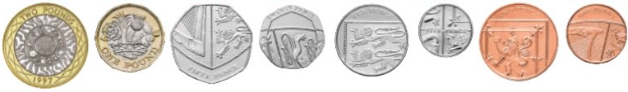
Which coin has the largest value? Which coin has the smallest value?

Task 1

Count the money in the pictures below. What counting strategies could you use to help you?
REMEMBER!
When we write a value in pence, the ‘p’ goes after the number.
10p + 10p = 20p
When we write a value in pounds, the ‘£’ goes before the number (and we don’t put the ‘p’).
£1 + £1 = £2

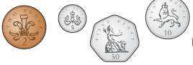
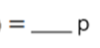
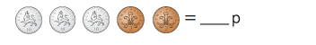




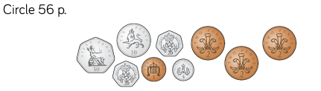

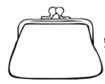
Draw coins on the purses to make the correct amount.
39p
74p

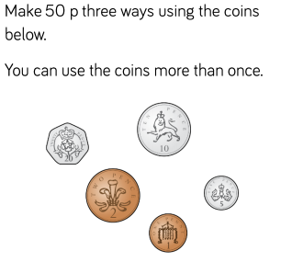
Challenge

Task 2
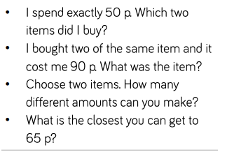
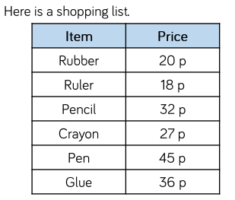

Challenge
Can you create your very own shopping list for the supermarket?
Make a list of all the items you will need to buy, and how much each item will cost. (Perhaps research online how much they are. Mrs Machin has spent a lot of time on the Asda website!)
Let’s see if you can add all of the amounts together to work out how much your shopping will cost in total!

