22.4.2020

My Worry Monster
My monster name:
My worry monster looks like:
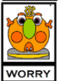
Write about when your worry monster arrives. What makes you feel worried? What helps you get back to your upstairs brain?

