Summer Term 1: Week 2 20.4.20
Sports challenge

Hello year 2!
Your sports challenge this week is a competition… with yourself!
Each day, if you can, I’d like you to have a go at the following and see if you can beat it each day:
- How many “keepy-uppy’s” you can do in a row without dropping the ball?
- How many hula hoops can you swing round your hips in a row without stopping?
- How long can you skip for without stopping?


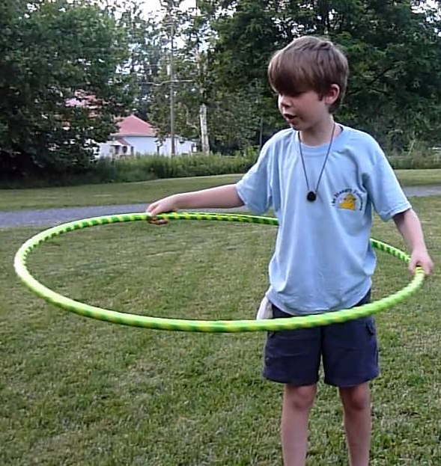

Challenge:
- Can you do your keepy-uppy’s with alternating feet each time?
- Can you cross your skipping rope each time you skip? Can you do any other tricks with your skipping rope?
- Can you balance something on your head whilst you do your hula hoops?

