Summer Term 1: Week 2
Maths Task 3 - pictograms

Look carefully at the Pictogram below and answer the questions.
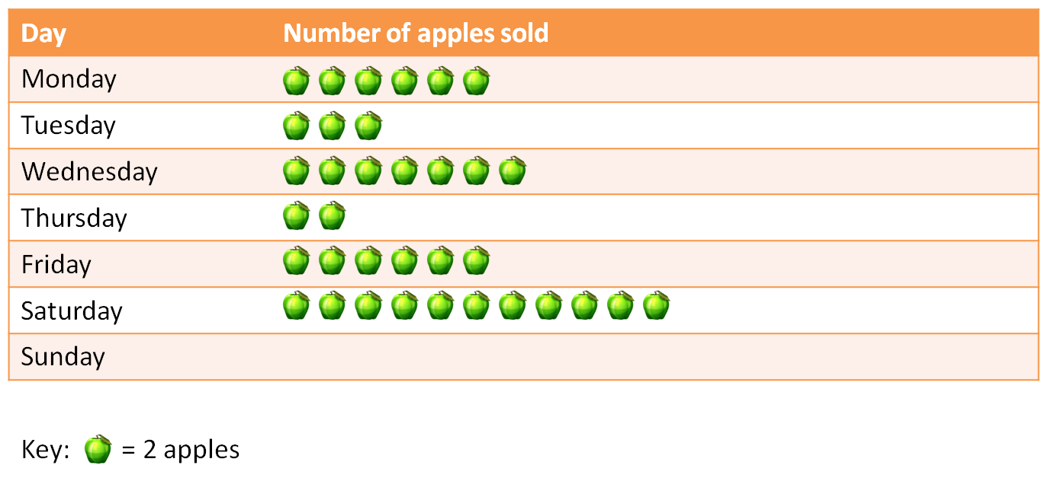
Key: = 1

- Five apples were sold on Sunday. Complete the pictogram to show this.
- How many apples were sold on Friday? ________________
- What was the total amount of apples sold on Monday and Tuesday? ________________

- The shop sold the most apples on _______________________.
- The least amount of apples were sold on _____________________.

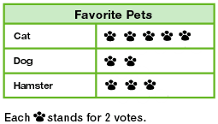
Challenge!

- Which pet got the most votes? _____________
- Which pet got the smallest amount of votes? ________________
- How many people chose cats as their favourite pet? _______
- _______ people voted for Hamsters.

