Summer Term 1: Week 1 w/c 14.4.20

Computing task – Changing the font, size and colour of a piece of text.

We all hope that you have been keeping busy and having fun at home over the last few weeks.
Miss Shaw has been writing a diary to remember all the fun things that she has been doing during her time out of school, which has given me a great idea for a computing task.

For your computing task, I would love to hear what you have been up to these past few weeks. Instead of writing this down on a piece of paper, I would like you to type this out on a computer or laptop. I would like you to include: your routine (if you have one), what you have been doing, who you have spent time with, and what your favourite thing to do has been. You only need to do a few sentences on this, don’t worry about writing a full page!

Once you have done this, I would like you to have a go at:
- Changing the font of your writing.
- Changing the size of your writing.
- Changing the colour of your writing.

Here is a reminder of what to do:

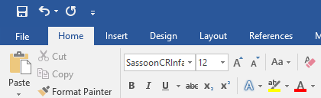
To change the colour; highlight the text, click on the drop down arrow here and choose from the different colours available.

To change the font; highlight the text, click on the drop down arrow here and choose from the different fonts available.
To change the size; highlight the text, click on the drop down arrow here and choose the size.

Challenges:
Can you add an image to your work from either your computer or a relevant picture from the internet (with supervision from an adult)?
Can you save your work in an appropriate folder on your computer or laptop?

