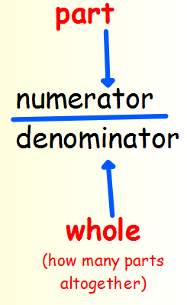
Summer Term 1: Week 1
Maths Task 4 – fractions of amounts

A fraction is an equal part of a whole. When we write a fraction we have 2 parts – the denominator and the numerator.

For example; ½ is 1 part of 2 equal parts
¾ is 3 parts of 4 equal parts
We can find fractions of numbers, like we found fractions of shapes.
You can use cubes to help you find these fractions of numbers, or draw the groups out. Make sure you have an equal number of cubes or lines in each group!
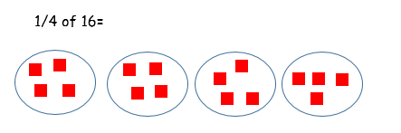
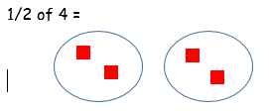

Can you find:
½ of 10
½ of 26
½ of 4
½ of 12

Can you find
1/3 of 9
1/3 of 15
1/3 of 3
1/3 of 30

Can you find
¼ of 4
¼ of 16
¼ of 24
¼ of 36

Challenges! (Change the colours if you don’t have matching colours at home)
Can you make a cube tower with 12 cubes that is ½ red, ¼ blue and ¼ yellow?
Can you make a cube tower with 20 cubes that is 2/4 black, ¼ red and ¼ green?
Can you make a cube tower with 12 cubes that is 1/3 blue, ¼ white and the rest brown?

