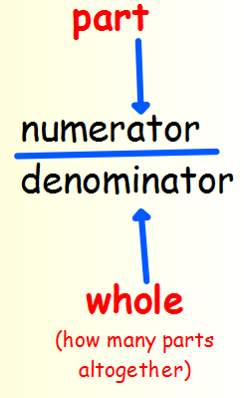
Summer Term 1: Week 1
Maths Task 3 – fractions of shapes

A fraction is an equal part of a whole. When we write a fraction we have 2 parts – the denominator and the numerator.

For example; ½ is 1 part of 2 equal parts
¾ is 3 parts of 4 equal parts

Can you find things around your house that you can split into fractions of halves, thirds or quarters?
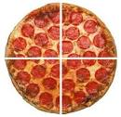
This might be a pizza that you can cut into quarters. Can you take photographs or draw pictures of the object as a whole and in the fractions you created?
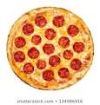


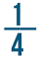
Each part of the pizza is Two pieces of the pizza would be

Can you show 2/4, ¾ or 2/3 of the objects you have used?

