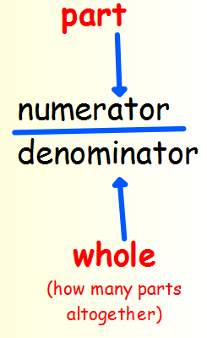
Summer Term 1: Week 1
Maths Task 2 – fractions of shapes

A fraction is an equal part of a whole. When we write a fraction we have 2 parts – the denominator and the numerator.

For example; ½ is 1 part of 2 equal parts
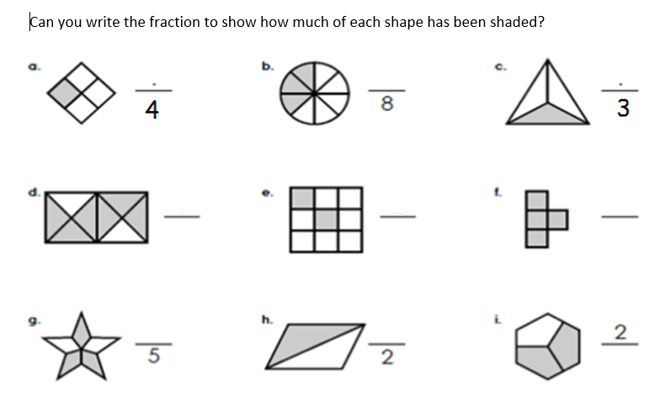
¾ is 3 parts of 4 equal parts

Now can you colour the fractions of the shapes below?
You can either print these shapes below or draw your own out to colour:
