Summer Term 1: Week 1
Maths Task 1 – 2D shapes and lines of symmetry

We all hope that you have been keeping busy and having fun at home over the last few weeks.
Miss Hughes liked eating her Easter egg and seeing lots of photographs of her family and friends having Easter egg hunts with their families over the weekend and that gave me an idea for some maths we can do!
Can you draw the lines of symmetry on these Easter pictures?
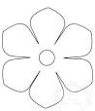
One of them doesn’t have a line of symmetry –can you find which one that is?
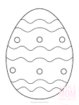
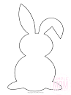
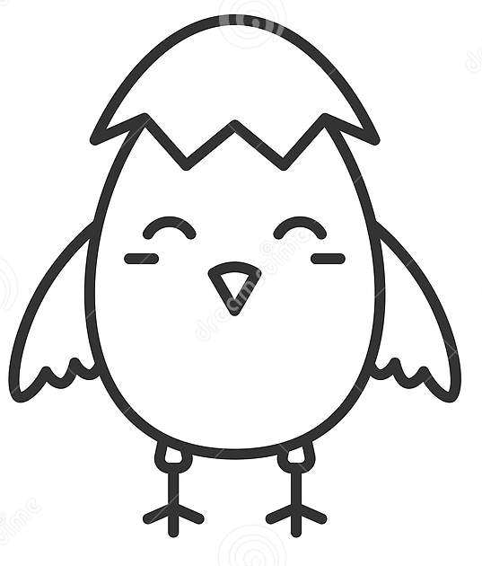

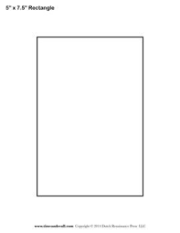
Can you cut some 2D shapes out of paper and fold them along their lines of symmetry?

Write the name of the shape and the number of sides and corners on it and fold it so each side matches up. You could decorate the shapes with Easter pictures on.
See the example below:

Rectangle
4 sides and 4 corners
2 lines of symmetry

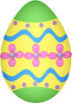
Challenge!
Symmetry means it is the same on each side – like this Easter egg!
Can you design an Easter egg with a symmetrical design, or finish the symmetrical egg patterns on the separate sheet?

