Communication and Language  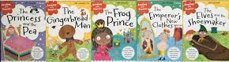  Retell a fairy tale or traditional tale that you know well. You might like to video yourself telling the story and send it to your class teacher to play during story time! | Personal, Social and Emotional Development  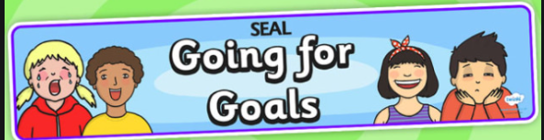  Talk about how you can achieve your goals. What will you need to do in order to get better? Complete the ‘Going for Goals’ activity if you haven’t already and return it to school for our SEAL display. | Physical Development  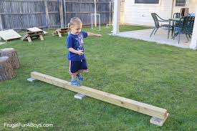  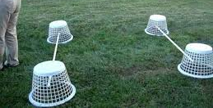  Design and then build an obstacle course in your house or garden, and practise balancing on top, crawling underneath, and moving forwards, backwards and sideways.
Reading    Use your Bug Club login (password sent home on blue bookmark).  Read, or watch, ‘The Highway Rat’ using the link below and talk about the main events in the story. Is the Highway Rat a hero or a villain? How would you feel if he stopped and took your dinner away?  https://www.bbc.co.uk/iplayer/episode/b09kkt1k/the-highway-rat | Writing  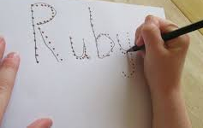  Practise writing your name. Remember to hold your pencil near to the tip!  Have a go at our wanted poster to catch the Highway Rat (attached to the gallery page). Think about what he looks like, what he sounds like, and what he does. Use the sound mat attached to write down the sounds you can hear in each word in your sentence. | Number and Numerical Patterns  We are working on recognising teen numbers. Play number bingo (attached) with a family member. Who will be the first to cross off all of their numbers?  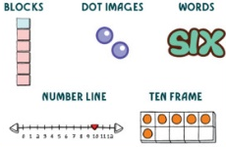  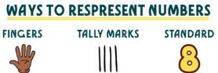  You can also find different ways to make teen numbers at home. You can use anything that you find around the house.
Understanding the World  Explore which objects float and which objects sink at home with a grown up. Choose some objects from around your house and first predict which ones will float and which will sink. Why do you think this might happen? Have fun testing your predictions! You might like to use the recording sheet on the gallery page to write down your results. | Expressive Arts and Design  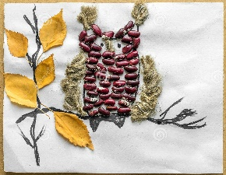  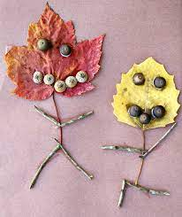  Use natural objects that you can find in the garden to create your own picture. You could make shapes, patterns, or even a rocket! Here are some examples to get you started.  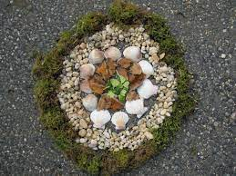 | Useful websites to practise and consolidate learning  www.topmarks.co.uk – select Early Years and choose from the games and activities listed.  www.phonicsplay.co.uk – select Resources, and then either Phase 1 or Phase 2.  http://www.crickweb.co.uk/Early-Years.html - select Early Years choose from the games and activities listed.
Foundation Stage 2 – Home Learning Menu wc 24th January 2022
