
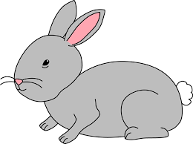
Home Learning Challenge 23/3/20
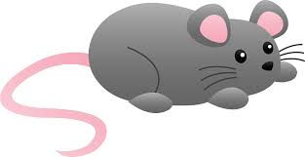
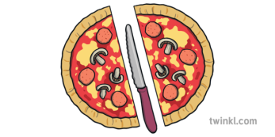
Challenge 1 – Halving
Choose a number card (even numbers to 20)
Count out the same number of objects.
Can you find half of the number?, how many objects in each half?
Extension – Which numbers between 1 – 20 can you halve?
Can you make a card folding your paper in half?
What can you halve in your house? E.g. half of a cake?
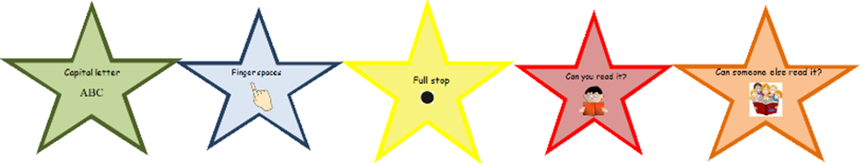
Challenge 2 – Write a Description
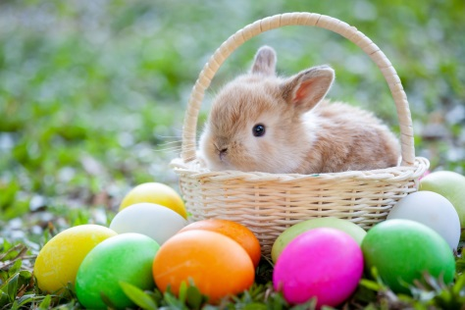
Can you write three sentences to describe how you imagine the Easter bunny to look?
Check your writing, with our writing stars:
Capital letters, full stops, finger spaces,
Can you read it, can someone else?

Are your tricky words spelt correctly

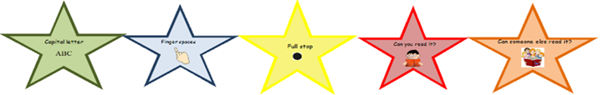
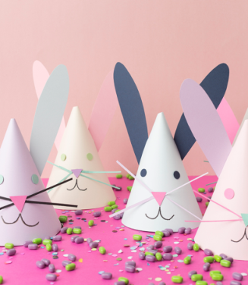
Challenge 3 – Make your own Easter bunny
You will need: card, glue, scissors, pens
Draw around a large circle shape and cut out.
Cut in a straight line to the centre.
Pull around to make a cone and fasten with glue
Cut out ears and draw on a face

