me | my | was
they | are | his
her | then | that
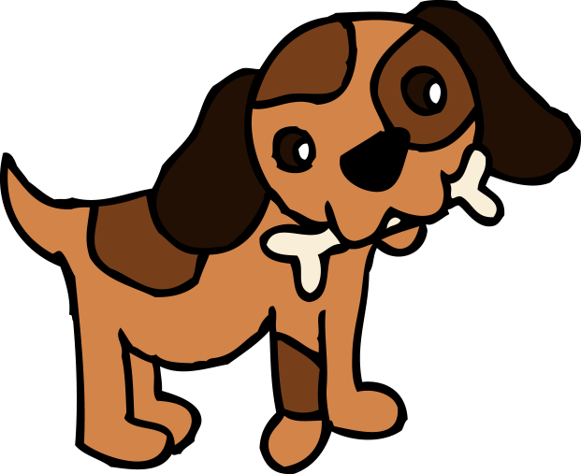
Spelling Zapper 2
Practise reading, writing and spelling aloud the words below.
When your children can read, write and spell the words below put a “Z” in the corner of the word.
When they have 4 zaps on each word bring it back to school so your teacher can test your child and they can get a new spelling zapper

