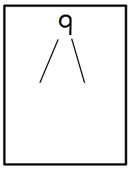
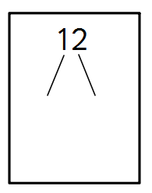
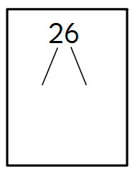
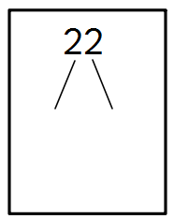
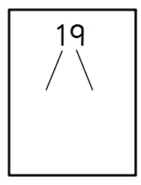
Draw out the 10s and ones for these numbers:
33
25
27
10
34
42
Draw your array for the calculations.
One has been done for you.

5 x 3 =
2 x 4 = 8

2 x 3 =
3 x 4 =
2 x 2 =
5 x 2 =

