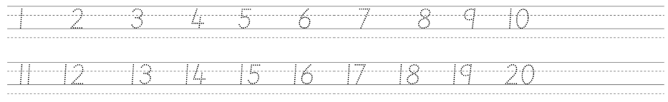

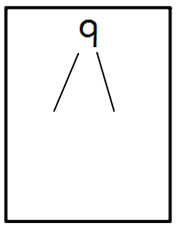
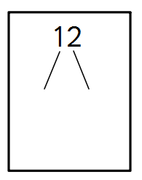
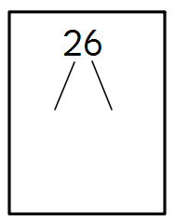
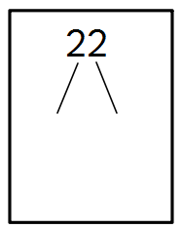
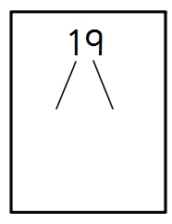
Draw out the 10s and ones for these numbers:
17
26
33
43
15
39
Draw your tens and ones for the calculations.
One has been done for you.

12 + 7 =
11 + 6 =
13 + 5 =

18 - 7 =
16 - 4 =
14 - 2 =

