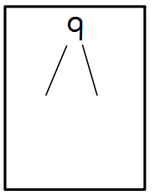
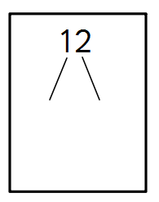
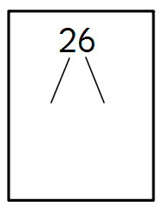
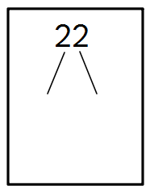
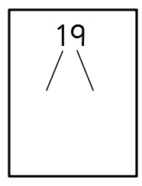
Draw out the 10s and ones for these numbers:
36
23
47
21
13
29
Draw your groups for the calculations.
One has been done for you.

15 ÷ 3 =
8 ÷ 4 = 2

10 ÷ 2 =
12 ÷ 3 =
12 ÷ 2 =
25 ÷ 5 =

