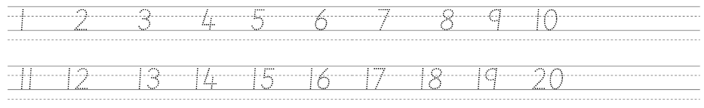

18 + 21 = | 19 – 13 = | 1/3 of 15 = | 4 X 5 = | 12 ÷ 4 =
32 + 26 = | 28 – 14 = | 1/2 of 12 = | 3 X 4 = | 20 ÷ 5 =
25 + 19 = | 22 – 8 = | 1/4 of 8 = | 8 X 10 = | 15 ÷ 3 =

