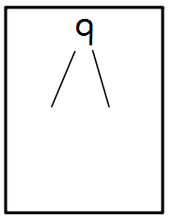
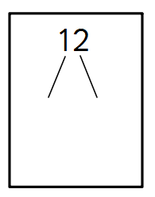
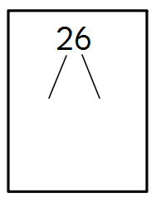
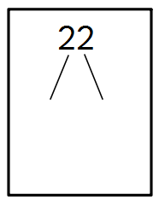
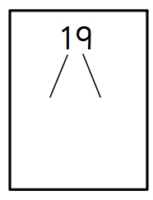
Draw out the 10s and ones for these numbers:
19
22
31
40
14
35

Draw out the 10s and ones for these numbers:
17
26
28
30
21
43

Draw out the 10s and ones for these numbers:
29
32
11
44
27
15

