Look at the underwater picture.
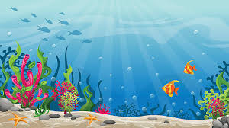
Use the nouns, verbs and adjectives table to create some vocabulary for the picture.

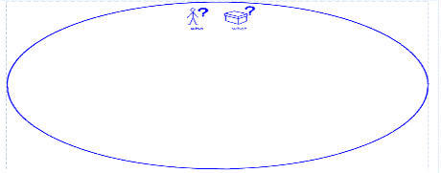  nouns | 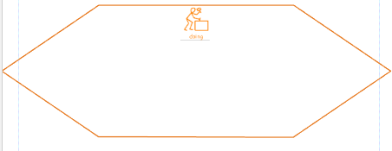  verbs | 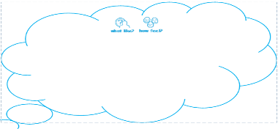  adjectives
Create some expanded noun phrases for the picture.
Then put your expanded noun phrases into compound and comple sentences.
