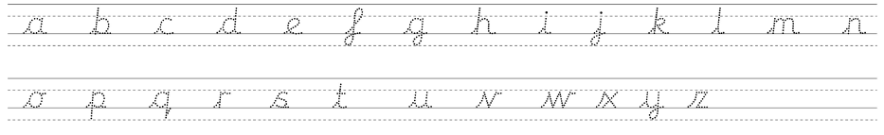

  adjectives |   nouns | 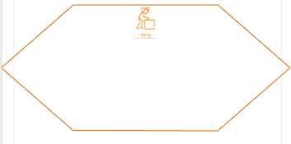  verbs | adverbs
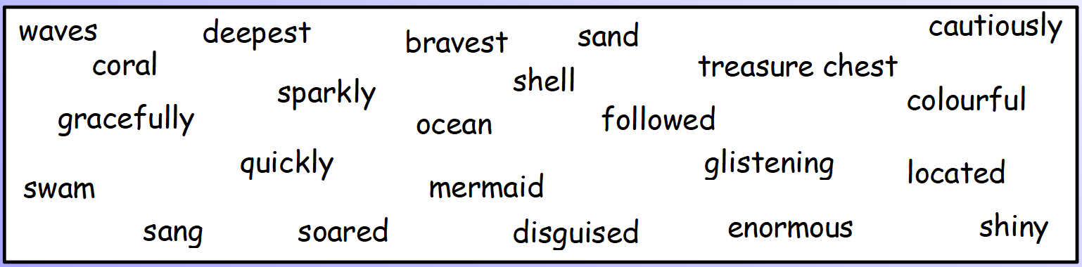



Write some interesting sentences using all of the word types which you could use in your own story.
Can you include different sentence types (compound/complex)?

